Practical 3

Scanner class
The Scanner class is a class in java.util package. The Scanner class is a class which allows the user to get input/read values of various types from keyboard. There are numbers of methods supported by the Scanner class. You may refer to Java API for more details about Scanner class.

Example of Scanner class:

import java.util.Scanner;

public class Scanner_Example
{
public static void main(String [] args)
{
String student_name;

Scanner in;
in = new Scanner(System.in);
System.out.println("Please enter your name");
student_name=in.nextLine();
System.out.println("Your name : "+ student_name);
}
}

Question 1
Write an application that reads three integers and prints their average.

Question 2
Write a program which will read a String from user by using the Scanner class. Your program should also show the letter appear in position 1,3,5 in your input. Hints: You can refer to String in Java API.

Question 3
Write an application that reads values representing time duration in hours, minutes, and seconds and then prints the equivalent total number of seconds. (For example, 1 hour, 28 minutes, and 42 seconds is equivalent to 5322 seconds.)

Question 4
Write a program that reads two numbers and return the bigger number of the inputs. Hints: You may refer to the functions in Java API.

Question 5
Create a program which will read the "Object oriented Programming using Java" from keyboard and displays in Four different formats as follows:
1. Displays the string in CAPITAL letter.
2. Displays the string in SMALL CAPITAL letter.
3. Return the number of character in the string.
4. Replace the character 'o' with character 'k'.

Diagram below show the sample output.
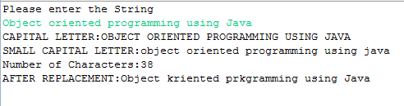

Question 6
Get a string/sentence from user and by using StringTokenizer class (FROM API: Hints Java.util package), create tokens and display the NUMBER of TOKENS from the sentence to screen.

Question 7
The Random class implements a random number generator, which produces sequences of numbers that appear to be random. To generate random integers, you construct an object of the Random class, and then apply the nextInt method. For example, the call generator.nextInt(6) gives you a random number between 0 and 5. Write a program LuckyDraw that uses the Random class to simulate the Lucky Draw pick, printing a random number between 1 and 100 every time the program is run. Hints: You may refer to Random class in API.

